**Sprint 1 Manual Testing Report**

Team 18: Chunao Liu, Anurag Shah, Jenna Zhang, Yierpan Abuduwaili, Michelle He, Jingyuan Yang

**User Story #2: As a user, I would like to be able to sign into my account.**

Valid account info: username: “admin”, password: “666”

* Test Case 1:

Input: username: “admin”, password: “1234”

Output:

o Backend: Responds with code -1, msg: "Wrong password!"

o Frontend: Error message displayed: “Incorrect username/password”

Acceptable? - Yes

* Test Case 2:

Input: username: “admin”, password: “666”

Output:

o Backend: Responds with code 0, msg: "Login Successfully!"

o Frontend: Success displayed and redirected to Camera Page

Acceptable? - Yes

* Test Case 3:

Input: username: “ad”, password: “1234”

Output:

o Backend: Responds with code -2, msg: "User does not exist!"

o Frontend: Error message displayed: “Incorrect username/password”

Acceptable? - Yes

**User Story #3: As a user, I do not need to log in again if I’ve logged in before and did not log out.**

Backend authentication will be implemented in Sprint2

* Test Case 1:

Input: ‘Remember me’ checked when user first log in

Output:

o Backend: N/A

o Frontend: Click Login Button on CameraPage, ‘Already Login msg” displayed.

Acceptable? - Yes

* Test Case 2:

Input: ‘Remember me’ checked when user first login

Output:

o Backend: N/A

o Frontend: Logout and login again, the username and password are autofilled

Acceptable? - Yes

* Test Case 3:

Input: ‘Remember me’ unchecked when user first login

Output:

o Backend: N/A

o Frontend: Click Login Button on CameraPage -> Redirected to LoginPage.

Acceptable? - Yes

* Test Case 4:

Input: ‘Remember me’ unchecked when user first login

Output:

o Backend: N/A

o Frontend: Username and password fields are empty on LoginPage .

Acceptable? - Yes

**User Story #4: As a user, I would like to have a way to reset my password.**

Still working on backend code, so currently no response from backend

A valid email address: admin@gmail.com

* Test Case 1:

Input: Click ‘Forgot password” on LoginPage

Output:

o Backend: N/A

o Frontend: Prompt users to enter their registered email

Acceptable? - Yes

* Test Case 2:

Input: email: admin

Output:

o Backend: N/A

o Frontend: Error message displayed: “Please enter a valid email address”.

Acceptable? - Yes

* Test Case 3:

Input: email: adm@gmail.

Output:

o Backend: Responds with code -2, msg: "Wrong username!"

o Frontend: Error message displayed: “No account found ”

Acceptable? - Yes

* Test Case 4:

Input: email: admin@gmail.

Output:

o Backend: Responds with code -2, msg: "Wrong username!"

o Frontend: Success message: “Password reset link successfully sent ”

Acceptable? - Yes

**User story #5: As a user, I would like to be able to create my own account.**

Backend communication will be done in Sprint 2.

* Test case 1:

Inputs:

* + Username: michelle
  + Email: michelle
  + Password: abc
  + Confirm Password: abc

Outputs:

* + Backend: N/A
  + Frontend: error message: “invalid email!”

Acceptable? - Yes

* Test case 2:

Inputs:

* + Username: michelle
  + Email: michelle@gmail
  + Password: abc
  + Confirm Password: abc

Outputs:

* + Backend: N/A
  + Frontend: error message: “invalid email!”

Acceptable? - Yes

* Test case 3:

Inputs:

* + Username: michelle
  + Email: michelle@gmail.c
  + Password: abc
  + Confirm Password: abc

Outputs:

* + Backend: N/A
  + Frontend: error message: “Invalid Email!”

Acceptable? - Yes

* Test case 4:

Inputs:

* + Username: michelle
  + Email: michelle@gmail.com
  + Password: abc
  + Confirm Password: ab

Outputs:

* + Backend: N/A
  + Frontend: error message: “Password Mismatch!”

Acceptable? - Yes

* Test case 5:

Inputs:

* + Username: michelle
  + Email: michelle@gmail.com
  + Password:
  + Confirm Password: ab

Outputs:

* + Backend: N/A
  + Frontend: error message: “Password Mismatch!”

Acceptable? - Yes

* Test case 6:

Inputs:

* + Long press password field

Outputs:

* + Backend: N/A
  + Frontend: do not show the context menu

Acceptable? - Yes

* Test case 7:

Inputs:

* + Long press confirm password field

Outputs:

* + Backend: N/A
  + Frontend: do not show the context menu

Acceptable? - Yes

**User Story #7: As a user, I would like to be able to see and edit my account information.**

* Test Case 1:

Input: checking account info page

Output:

o Backend: N/A

o Frontend: Redirected to account page when account is clicked

Acceptable? - Yes

* Test Case 2:

Input: editing account info at account info page

Output:

o Backend: N/A

o Frontend: Button clicked but nothing changes yet

Acceptable? - No

* Test Case 3:

Input: clicking “back”

Output:

o Backend: N/A

o Frontend: Button clicked redirects user to camera page

Acceptable? - Yes

**User Story #8: As a user, I would like to be able to take pictures of my code or import it from the gallery**

* Test Case 1:

Input: Taking picture

Output:

o Backend: Responds with code http 200 OK

o Frontend: Picture static but very zoomed in

Acceptable? - No

* Test Case 2:

Input: Importing image from gallery and sending

Output:

o Backend: Responds with code http 200 OK

o Frontend: Picture static and ready for processing

Acceptable? - Yes

* Test Case 3:

Input: Drop down menu navigation

Output:

o Backend: N/A

o Frontend: Redirection to account page works

Acceptable? - Yes

**User story #9: As a user, I would like to type the code in the text editor and run it.**

Backend communication will be done in later sprints.

* Test case 1:

Inputs:

* + User presses run button

Outputs:

* + Backend: N/A
  + Frontend: Pops up an alert window

Acceptable? - Yes

* Test case 2:

Inputs:

* + User presses cancel on alert window

Outputs:

* + Backend: N/A
  + Frontend: back to text editor page

Acceptable? - Yes

* Test case 3:

Inputs:

* + User presses submit on alert window

Outputs:

* + Backend: runs code(still in progress)
  + Frontend: Sends code to backend

Acceptable? - Yes (front end works although backend haven’t been implemented)

**User Story #12: As a developer, I would like to automatically compile the code given by the user and send the correct runtime result back to the user**

* Test Case 1:   
  Input: ‘#include<stdio.h>\n\nint main(int argc, char *argv[]) {\nprintf ("Hello World") ;\nreturn 0;\n\n}’  
  Output: Hello World  
  Acceptable: Yes
* Test Case 2:  
  Input: ‘aaaaa#include<stdio.h>\n\nint main(int argc, char *argv[]) {\nprintf ("Hello World") ;\nreturn 0;\n\n}’  
  Output: 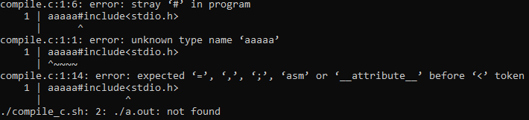  
  Acceptable: Yes (notably, the last line will have to be removed in post processing somewhere in the pipeline)

**User Story #14: As a user, I would like the application to process my image of typeform code, and convert it to the relevant textual representation.**

* All test cases for this portion are images. The goal is to ensure that the image produces the desired output. The test cases are located at WhiteBoard\Backend\OCR\images\tesseract_tests. Certain characters and font styles do fail the test case, but are maintained in the folder for future use. These test cases are manual, the main function inside ocr.py (in WhiteBoard\Backend\WhiteBoardBackEnd\API) has to be manually updated to run them.  
    
  As noted above, the expected output for each test case is the text in that image. The actual output varies as tesseract is not deterministic. An output is “acceptable” when very few characters are wrong.
* Test case 1:  
  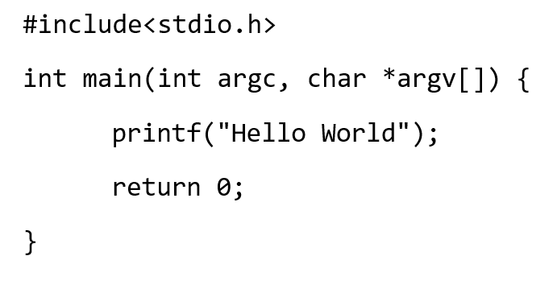  
  Acceptable: Yes
* Test case 2:  
  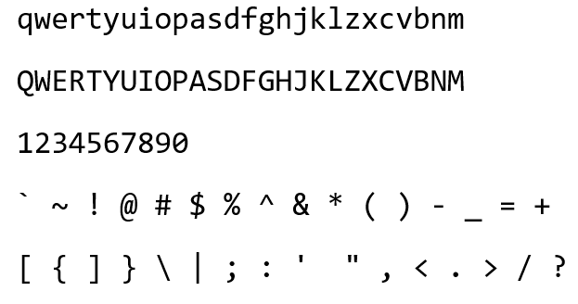  
  Acceptable: No
* Test case 3:  
  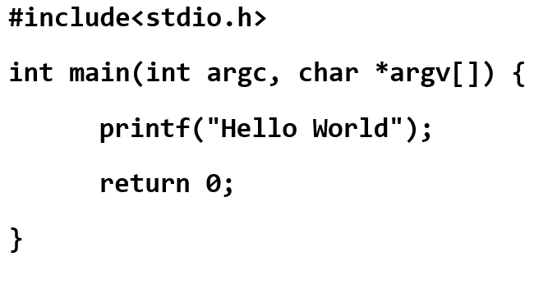  
  Acceptable: Yes
* Test case 4:  
  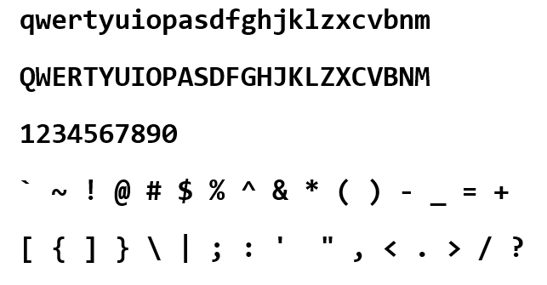  
  Acceptable: Yes
* Test case 5:  
  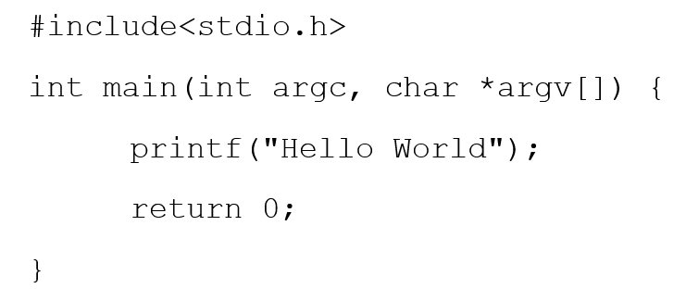  
  Acceptable: Yes
* Test case 6:  
  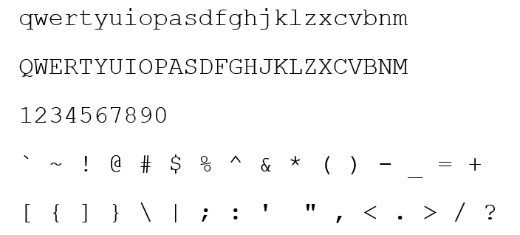  
  Acceptable: No
* Test case 7:  
  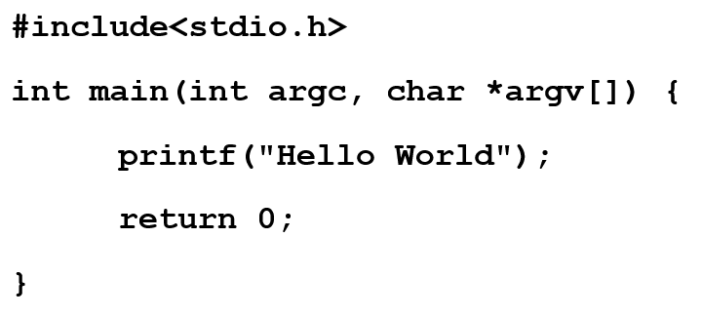  
  Acceptable: Yes
* Test case 8:  
  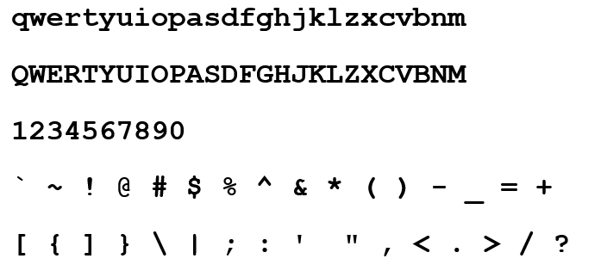  
  Acceptable: Yes
* Test case 9:  
  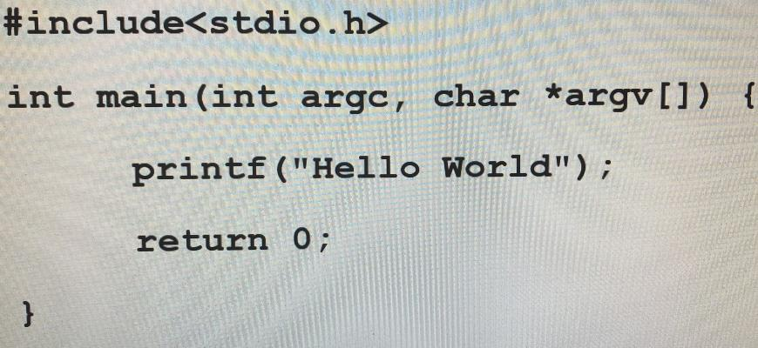  
  Acceptable: Yes
* Test case 10:  
  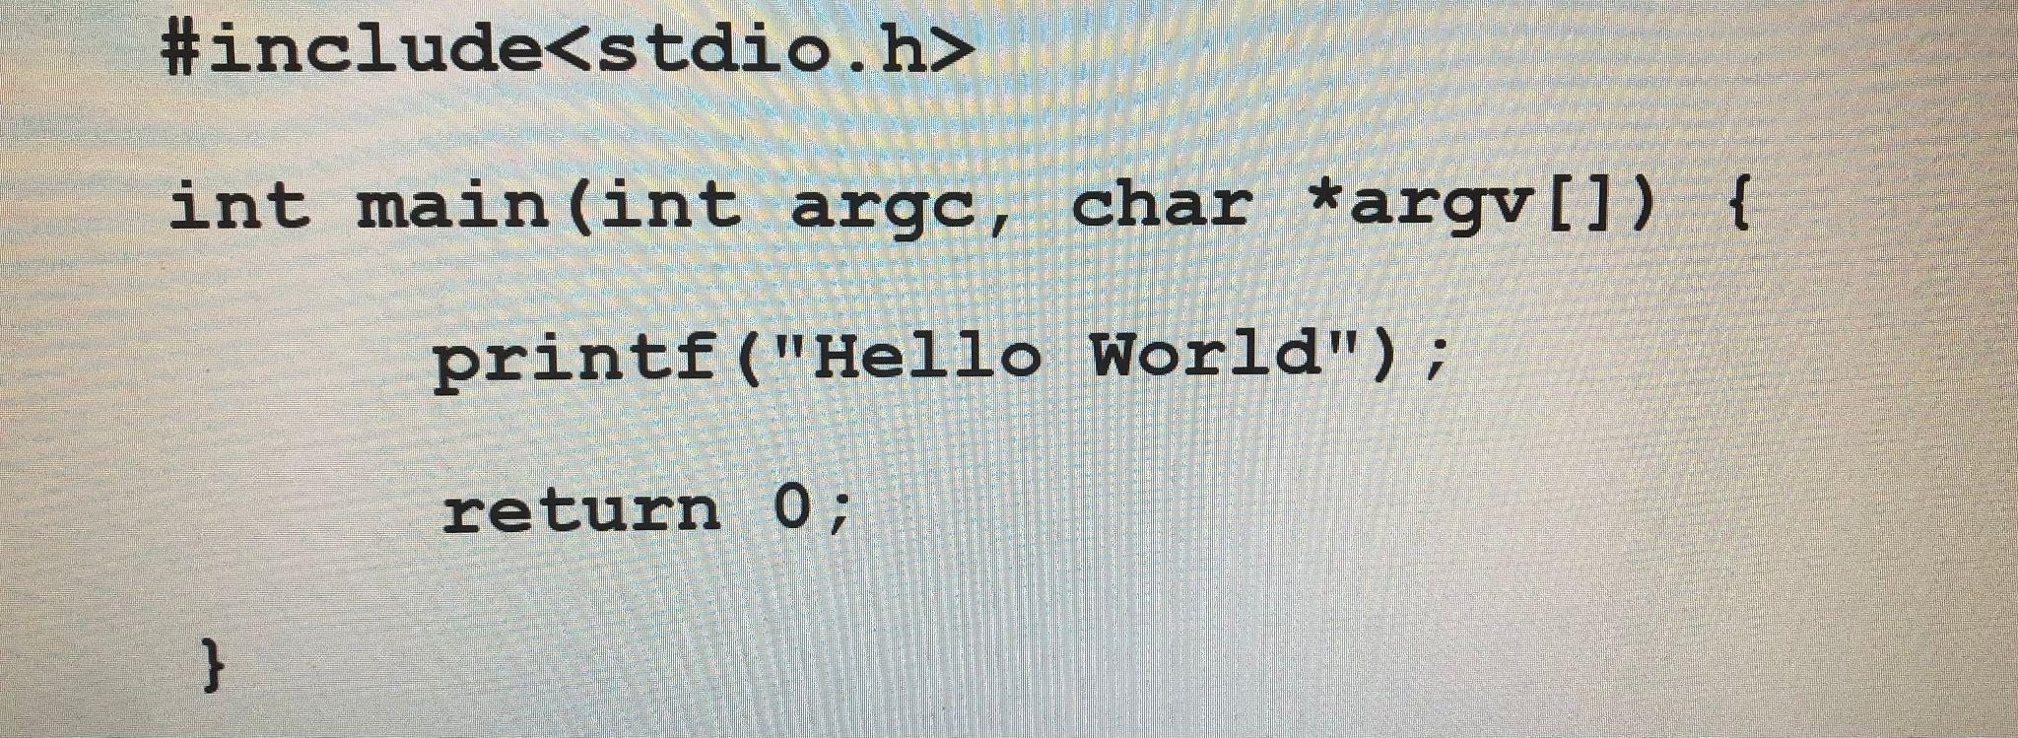  
  Acceptable: Yes
* Test case 11:  
  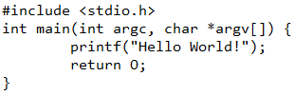  
  Acceptable: Yes
* Test case 12:  
  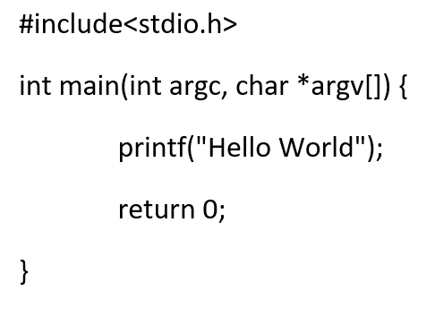  
  Acceptable: Yes
* Test case 13:  
  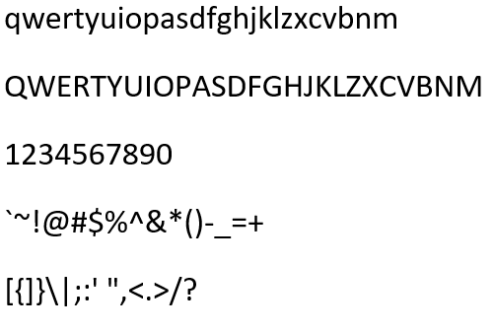  
  Acceptable: Yes
* Test case 14:  
  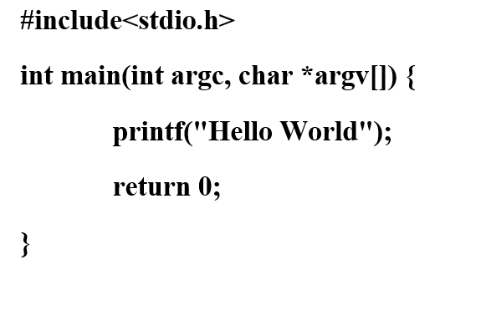  
  Acceptable: Yes
* Test case 15:  
  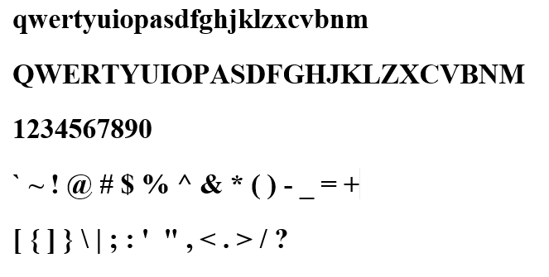  
  Acceptable: No